Spring Term 2024

 Perrymount Maths Newsletter

Times Table Rock Stars



Each week, we hold highly contested Rock Battles. Well done to everyone who took part. Just 5 minutes a day can make a huge difference to a child’s times table fluency or help their class win the Times Table Rock Star trophy in Friday’s assembly.

A huge well done to these players for winning the Most Valuable Player Award:

Year 3: **Florence, Amelia, Thomas, Hind.**

Year 5: **Ruby.**

Year 6: **Oumar, Sonny Boy, Halima.**

The winning class in the first half-term was: **Neverland (Y4)** with **5 wins** and the winning class in the second half term was **Hogwarts (Y6)**  with **6 wins.**

Investors Challenge

Year 5 and Year 6 were set an investment challenge. They had to invest in **three stalls** (or more) at the annual Christmas Fair with a ‘£25’ budget. Well done to **Kian** in **Year 6** who put **£10** and **£6** on the highest grossing stalls. Thank you PTA and everyone who attended the Christmas Fair.

Whiterose Maths



This year, Perrymount are using the Whiterose Maths scheme! The Whiterose Maths scheme of learning follows the national curriculum with a mastery approach to maths with a range of fluency, reasoning and problem-solving elements. They encourage the use of concrete, pictorial and abstract representations to develop deep understanding of mathematical concepts. The children have been working really hard and have used resources to support their understanding of place value, addition, subtraction, multiplication and division.

Solutions

**Score 5:** 2 + 3; 4 + 1

Score 6: 4 + 2; 3 + 1 + 2

Score 7: 4 + 3; 4 + 1 + 2

**24 Challenge:**

**3 x 5 = 15; 15 – 7 = 8;**

**8 x 3 = 24**

KS2 Maths challenge

24 Challenge:

**Make 24** using **ALL 4** numbers. You can use + - x or ÷ but you can only use the number once.

KS1 Maths challenge

Which pins must you knock down to score exactly 5?

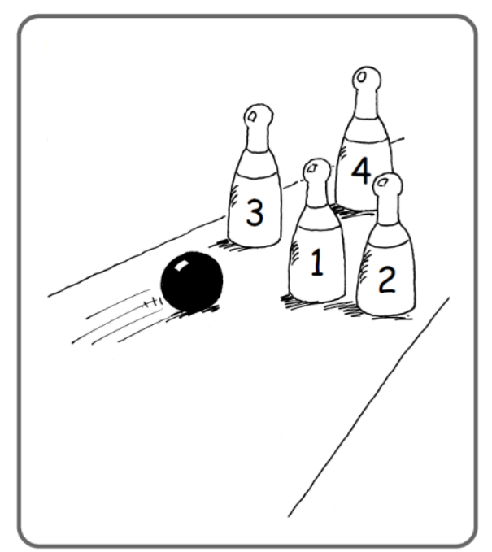

Find 2 different ways:

* To score 5
* To score 6
* To score 7

I hope you enjoyed this catch up.

**Mr Akinloye**

Maths Lead

**It has been a very busy term for Perrymount mathematicians. Here is a round up of maths at Perrymount.**