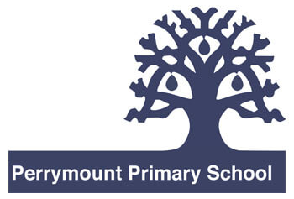
Spring term 2024
Perrymount Literacy Newsletter
Talk for Writing
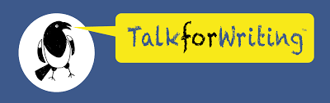
Talk for Writing is an engaging writing framework developed by Pie Corbett, which aims to create confident writers and storytellers. This approach is used throughout Perrymount from reception to year six. At Perrymount we focus on four purposes: Writing to entertain, writing to inform, writing to persuade and writing to discuss. Writing is celebrated through sharing of work and publishing for school displays. Here is a small insight into what each year has been writing about during the autumn term:
Reception: Crreated story maps. Year 1: Wrote a set of instruction on how to take care of a Bog Baby. Year 2: Retold a story inspired by ‘The Tunnel’. Year 3: Wrote an information text about earthquakes. Year 4: Wrote a setting description for ‘Varjak Paw’. Year 5: Wrote a portal story inspired by Narnia in ‘The Lion, The Witch and The Wardrobe’. Year 6: Wrote Remembrance Day Poems inspired by Dunkirk.

Writing Challenge – Imagination
This terms challenge is to write using your imagination and create something new. This could be a place, a character, story or even an invention. Bring them into school and share your ideas with your class.

Thank you for taking time to read our latest Literacy Newsletter.
Mr Santamaria
Literacy Lead

Reading for pleasure
Reading for pleasure opens up new worlds for children. It gives them the opportunity to use their imagination to explore new ideas, visit new places and meet new characters. Interestingly, reading for pleasure also improves children’s well-being and empathy. It helps them to understand their own identity, and gives them insight into the world and views of others.
KS2 Reading recommendations
LKS2: Rumaysa – Radiya Hafiza & Rhaida El Touny
The Land of Roar – Jenny McLachlan & Ben Mantle
Fantastically great women scientist and their stories – Kate Pankhurst (Non-fiction)
UKS2: Impossible Creatures – Katherine Rundell
High Rise Mystery – Sharna Jackson
Tales of Ancient Worlds – Stefan Milosavljevich (Non-fiction)
KS1 Reading recommendations
Reception: How to catch a star – Oliver Jeffers
Oi Frog! – Kes Grey & Jim Fields
First big book of why – Sally Symes & Stephanie Drimmer (Non-fiction)
Years 1 & 2:
Look Up – Nathan Bryon & Dapo Adeola
Billy and the Pirates – Nadia Shireen
The Big Book of Blue – Yuval Zommer (Non-fiction)

Reading
Reading is at the core of our curriculum and regular, daily reading is the key to reading success. We encourage parents/carers to listen to their children read at least four times a week but also discussing the book in increasing depth. Reading looks different across the school; Reception and KS1 have daily reading lessons and follow the Read, Write, Inc. scheme for phonics. In KS2, the children transition to a daily Destination Reader lesson where they continue to build upon their reading fluency but start to focus more on their reading comprehension.
The children have been working very hard on improving their literacy skills. Here is a taster of what we have been doing.

